**Lesson10 Introduction to Azure Batch Services**

**Notes: -**

**1-if we have requirement that we have App that get the videos from users and send the videos into multiple Azure into multiple VMS that processing the video spread into the VM’S and send to Azure storage Account > Blob storage**

**(you have to install the processing part as module in each VMS that receiving message)**

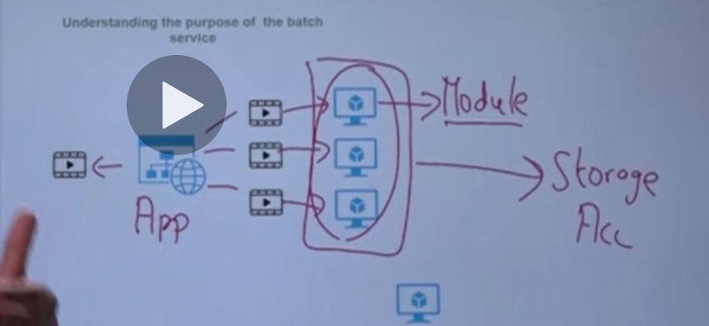

**2-so instead of handle it , you can create azure batch service that attached with azure storage account that attach the app with azure batch that referenced with multiple VM’S ,**

**So you need only to install module the Azure batch service instead to install module on each VM’S (the azure batch service called by app through API)**

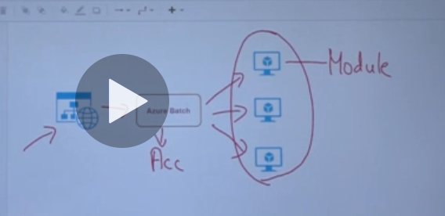

**Lesson11 Azure Batch Service Architecture**

**Notes: -**

**1-Azure batch service referenced with azure storage account that used to store the input and output files of azure**

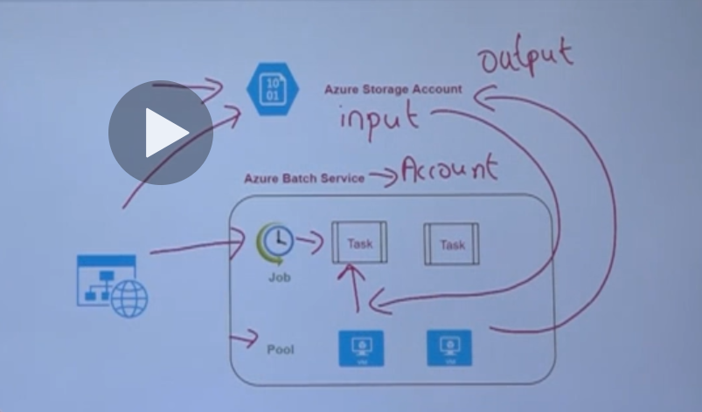

**Operations: -**

**1-the Module that represent the C# code for processing video is stored inside the Azure batch account**

**2-when the user upload video it will store the Azure storage account as input**

**3-the Azure Batch service will take the video and create new Job and load module from azure storage account with assign Task and Pool**

**4-each Azure Pool represents the Azure VM that processing the video**

**5-it will send the output and send the output into the Azure storage account**

**Lesson12 Azure Batch Service Important Points**

**Notes: -**

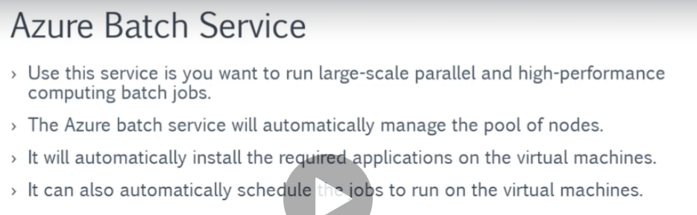

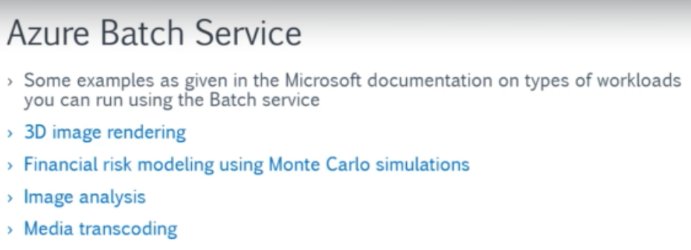

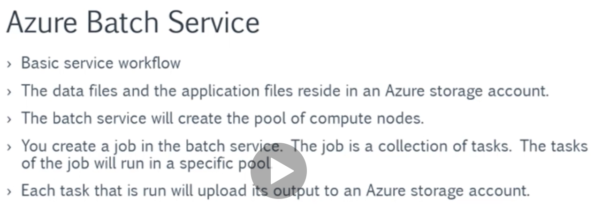

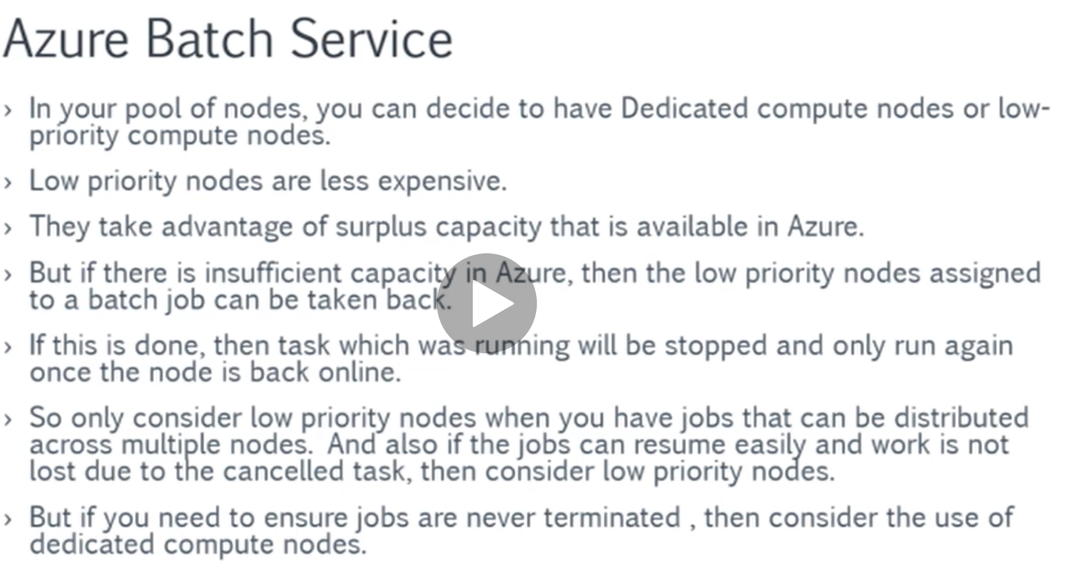

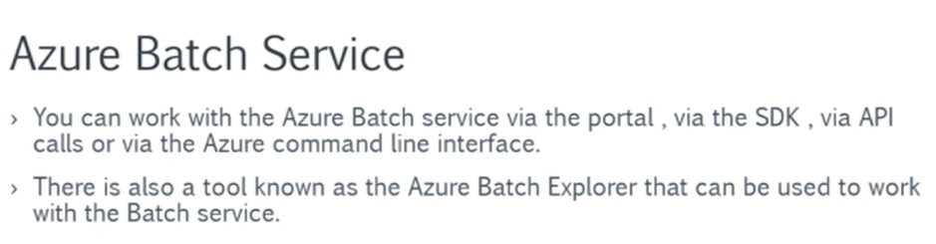

**Lesson13 Steps on apply Azure batch service**

**Steps: -**

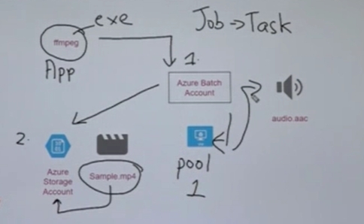

**1-create azure batch account**

**2-create azure storage account that used to store video and attached with azure batch service**

**(video like sample.mp4 is stored inside Azure storage account)**

**3-downlaod free tool called ffmpeg that used to record and convert the video from type to another or extract the video**

**(ffempeg is associated with Azure Batch Account and)**

**(ffmpeg like an module will be applied on the azure batch service)**

**4-create 1 dedicated pool VM**

**(so, the process is the following)**

**Azure batch service will create job with Task (can add multiple node with multiple tasks) and each pool will take the executable exe from azure batch account and take the video from the azure storage account and do processing and send output into the azure storage account as output as audio file**